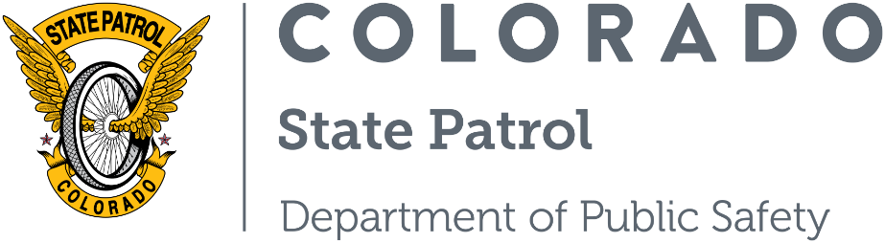

PRESS RELEASE

FOR IMMEDIATE RELEASE on: June 30, 2025
CONTACT
Captain Matt Ozanic
Matt.ozanic@state.co.us
(970) 858-2250

Safe Roads, Safe Summer Focuses on Reducing Impaired-Caused Crashes in July

(COLORADO) – Mesa County: In 2024, 214 people lost their lives in a crash involving an impaired driver in Colorado. While there are many causes of crashes, there is no excuse for getting behind the wheel after consuming alcohol, cannabis or other substances that impair your ability to operate a vehicle.
As we dive into the second, and likely deadliest month of the “100 deadliest days” for 2025, it is very important for everybody to act safely in hopes of saving lives on the streets, roads, highways, and even sidewalks of the Grand Valley. While law enforcement will be out enforcing these laws, the safety of our communities relies on everybody to play an active role. Let’s work together this year to make sure everybody gets to that family gathering, that ball game or BBQ alive.
As a driver:
- Never get behind the wheel after consuming alcohol, cannabis or other substances that may impair your ability to drive. As we’ve all heard many times, buzzed driving is drunk driving.
- Plan before your outing, even if there is a chance you may become impaired and commit to that plan. There is no excuse to drive impaired options like rideshares, public transportation, and designated drivers available.
- For passengers, don’t put your lives in the hands of an impaired driver, either. If your driver is impaired, speak up, act, and get yourself and others to your destination safely. All too often, it is the passengers who suffer in an impaired driving-caused crash.
As pedestrians, bicyclists and other roadway users:
- With all the festivals, concerts and ball games that go into the evening hours, be very cautious when crossing streets. There is increased traffic, unfamiliar traffic control patterns and even impaired drivers. Cross streets at lighted crosswalks and wait for the direction of the signal or traffic control professionals.
- Law enforcement understands that many people have the best interests of themselves and others when choosing not to drive a motor vehicle impaired. But scooters, bicycles and other powered vehicles are not a safe alternative to driving a car or truck while impaired. These transportation devices can be just as dangerous as getting behind the wheel of a motor vehicle, and in Colorado, the DUI laws apply to bicycles, low-powered scooters and even pedestrians and equestrian riders. When it comes to the need to get somewhere when you are impaired, put your safety in the hands of a sober driver. Don’t cut corners and attempt to “MacGyver” your way home.
Throughout the summer, public safety providers from Colorado State Patrol, Grand Junction Police Department, Grand Junction Fire Department, City of Grand Junction, Colorado Department of Transportation, Colorado Mesa University, Mesa County School District 51 and Bureau of Land Management are teaming up to bring our communities Summer Safety Education Tips. We hope everybody has a safe and enjoyable 2025 summer.

###
ABOUT THE COLORADO STATE PATROL
Since our origin in 1935, the Colorado State Patrol (CSP) has focused on preserving human life and protecting property within our communities. Our 1,100 members embody the core values of Honor, Duty, and Respect in their daily jobs. In addition to our expertise in motor vehicle safety on the state’s roadways, the CSP is responsible for the Governor and other dignitaries’ protection, commercial motor vehicle enforcement, hazardous materials, homeland security, communications, investigative services, criminal interdiction, community education, aviation operations, and more. For additional information, visit us online at Colorado State Patrol or follow us on Twitter, Instagram, YouTube, or Facebook.

